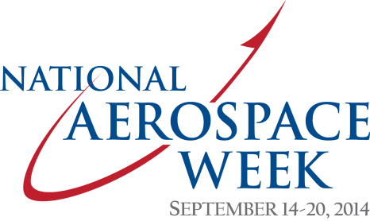

sample e-mail for employees

(Name of company or organization) has joined with the Aerospace Industries Association to celebrate National Aerospace Week, September 14-20, 2014.

This is an important time for our industry and our company (or organization). Now that the mid-term elections are in full-swing, it’s imperative that we communicate to elected officials that our entire industry – civil aviation, national security, and space – is a national asset that should not be taken for granted and is at risk on many fronts.

While some legislative measures have eased short-term budget cuts to our industry, we remain focused on the long-term budget concerns facing our industry and our company (or organization), as sequestration returns in full in 2016. We also need to make every effort now to communicate our strong support for reauthorizing the Export-Import Bank of the United States, which is due to expire on September 30, 2014.

To make our voices heard on these and other issues, I’m asking you to join the Second to None Coalition in the time leading up to National Aerospace Week. For nearly three years, the Second to None campaign helped change the tide of the debate for our industry in Washington, D.C., but the fight is not yet won. That is why we must speak with a single, unified voice to resonate in Congress and the Administration on issues important to the future of the industry. Like-minded supporters like you are critical to our success.

We’re a powerful force with enduring impact because our industry directly employs nearly one million workers, supports another 2.5 million jobs in all 50 states, and generates the largest foreign trade surplus of any manufacturing sector – a $72 billion foreign trade surplus in 2013. (name of company or organization) is part of this success story because of your work and the value you create for (name of company or organization) every day.

With members of Congress returning to their states and districts during this recess, now is the time to join with our colleagues across the industry who have already signed up as Coalition members to strengthen our industry’s future.

I’d also like to take this opportunity during National Aerospace Week to thank you for your long-standing contributions not only to our company but to the nation and to thank you for a job well done.

Our company is an important part of an industry that (core capability). We’re also an important contributor and member of our local community. Together, we make (name of region, state) and our nation great and create economic opportunity for many.

Signed/CEO

